 **NAME:** ALEENA SAEED

**PROGRAM:** BSCS

**COURSE TITLE:** WEB APP DEVELOPMENT (LAB-1)

**SEMESTER:** 4

**SAP ID:** 56270

**LAB 1 CLASS PRACTICE TASKS:**

**TASK 1:**

<!DOCTYPE html>

<html>

<head>

<body>

<p>

<h1>This is heading.</h1>

<h2>This is heading.</h2>

<h3>This is heading.</h3>

<h4>This is heading.</h4>

<h5>This is heading.</h5>

<h6>This is heading.</h6>

</p>

</body>

 </head>

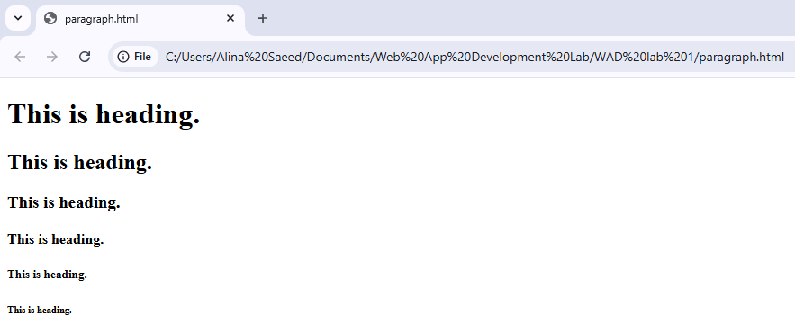</html>

**TASK 2:**

<!DOCTYPE html>

<html>

<head>

<title>t2</title>

</head>

<body>

<a href=https://moellim.riphah.edu.pk/enrol/instances.php?id=59105> link </a>

<img src="1.png">

</body>

</html>

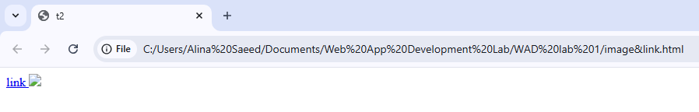

**TASK 3:**

<!DOCTYPE html>

<html>

<head>

<body style="background-color: aquamarine;">

<h1>This is a heading.</h1>

<p>This is a paragraph.</p>

<b>bold text</b>

<br>

<strong>Aleena</strong>

<br>

<i>italic text</i>

<br>

<em>emphasized text</em>

<br>

<mark>marked text</mark>

<br>

<small>small size</small>

</body>

 </head>

</html>

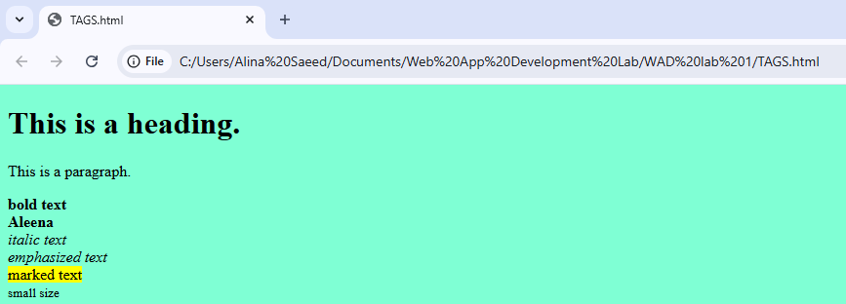

**TASK 4:**

<!DOCTYPE html>

<head>

<body>

<h2>An unordered HTML list</h2>

<ul>

<li>Coffee</li>

<li>Tea</li>

<li>Milk</li>

</ul>

</body>

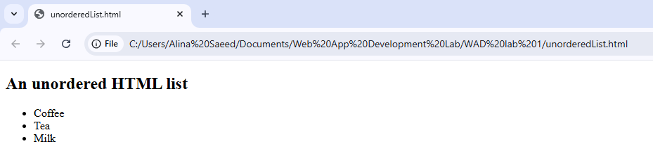</head>